**

**Mathematics Specialist Unit 1**

# Test 1

**Vectors**

|  |
| --- |
| **Name: ______________________ Total Marks:__________** |
|  |
|  |

**Task type: Response**

**Time allowed for this task:** 35 minutes, in-class, under test conditions

Calculator Free – 18 minutes

Calculator-assumed - 17 minutes

**Materials required:** Calculator with CAS capability (to be provided by the student)

**Standard items:** Pens (blue/black preferred), pencils (including coloured), sharpener, correction fluid/tape, eraser, ruler, highlighters

**Special items:**  Drawing instruments, templates, notes on one unfolded sheets of   
A4 paper, and up to three calculators approved for use in the WACE examinations

**Marks available: 35 marks**

**Task weighting: 3%**

**Calculator Free (18 marks)**

**Question 1: [1, 1, 1,2]**

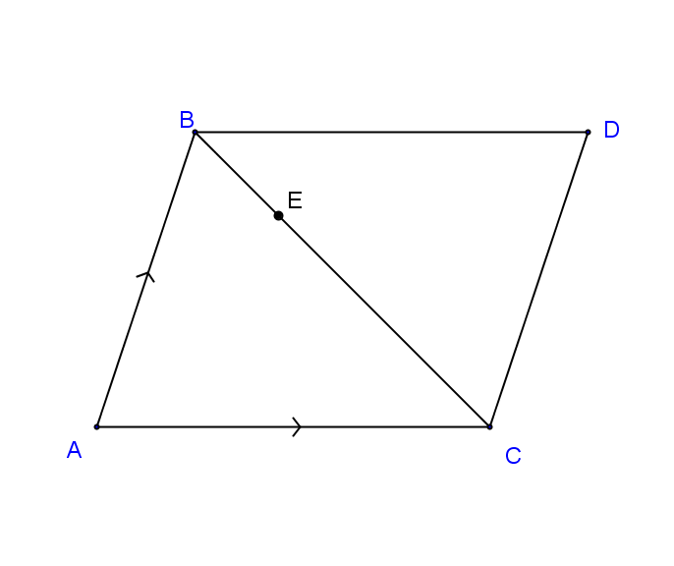

ABCD is a parallelogram with E a point on BC such that BE:EC = 1:3.

If $\vec{AC}= a$ and $\vec{AB}= b$**.** Express in terms of $a$ and $b$

$\vec{DC}$

$\vec{AD}$

$\vec{BC}=$

$\vec{DE}=$

**Question 2: [2, 2]**

A force of 46N is acting on an object in the direction of 210 $°$.

1. Write this force in component form where $i$ is a unit vector due east and $j$ is a unit vector due north.
2. A second force acts on the object to keep it in a state of equilibrium. What is the magnitude and direction of this force?

**Question 3: [1, 1, 3, 2, 2 marks]**

If **a** = 5**i** – 12**j**and **b** = -3**i** – 4**j**,

a) Determine |**a**|.

b) Determine **a** - **b**.

c) Find a vector in the same direction as **b**, with the same magnitude as **a**.

d) Determine the unit vector in the direction of **a** - **b**.

e) Show that (2**a** – 6**b**) is parallel to the *x*-axis.

**Calculator Assumed (17 marks) Name: ____________________**

**Question 4: [5, 3]**

Two tugs pull an offshore drilling rig. The first tug applies a force of 5 500 N in direction 122° and the second tug applies a force of 6 000 N in direction 088°.

(a) Show that the resultant force applied by the two tugs has magnitude close to 11 000 N, and determine the angle that the resultant force makes with the direction of the force applied by the first tug boat. (5 marks)

(b) The second tug boat is asked to decrease the magnitude of the force it applies to reduce the resultant force to 9 000 N. Determine the percentage decrease required. (3 marks)

**Question 5: [5, 4]**

A plane flying at velocity 580 km/h is forced to make an emergency landing after it blew an engine. The closest safe landing point is at an airport on a bearing of 0230, 250 km away. There is a strong cross wind blowing **from** 2650 at 37 km/h.

a) In which direction must the pilot head to land the plane at the airport? (Draw a diagram to support your answer).

b) There is enough fuel to fly for 240 km in still air. Will the plane make it to the airport before running out of fuel? Justify your answer.

**End of Test**